(Approx. 1416 words)

Apple iOS Has Great Secret Features
By Bill Crowe, Instructor, Sarasota Technology Users Group, Florida
January 2018 issue, STUGMonitor
www.thestug.org
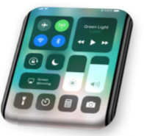
wtcrowe (at) verizon.net

This month I would like to look at some of iOS 11’s hidden beneath the surface features. Let’s start with some we use a lot the Keyboard....

Keyboard
One-handed keyboard on the iPhone – iPads have long had this feature, but in iOS 11 iPhone users can hold down the globe keyboard button and a mini keyboard will appear which can be attached to the left or right side of the display (as if the iPhone keyboard is not small enough already).
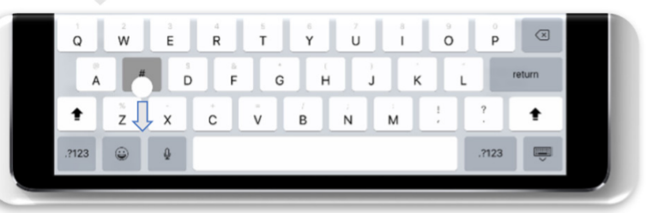

iPad extra symbols
Holding a key on some of the letters and symbols has long brought up alternative symbols and numbers, but now further alternatives can be accessed by pulling down on many keys.

Apple iOS 11 brings swipe down shortcuts to the keyboard.

Siri
Type to Siri. Now everyone wants to talk to Siri and now you can hack an Accessibility feature which allows you to type your question. Settings -> General -> Accessibility -> Siri -> Type to Siri. Next time you prompt Siri a keyboard will appear.

Siri Translation - Siri now supports spoken translation like Google Assistant. Simply ask “How to say [language] in [different language] and you will get a spoken and written answer. English, French, German, Italian, Mandarin Chinese and Spanish are initially supported.

Control Center
Customizable Control Center - Go to Settings -> Control Center -> Customize Controls and you can add shortcuts to Notes, Text Size, Stop Watch, Screen Recording (more later) and others. Note that the layout is fixed. Long Press Support - Previously 3D Touch was the only way to get quick access to contextual options in Control Center, but now these can be opened via a long press. For example, long press on the torch icon on the iPhone and you can adjust its brightness.


Maps
One Handed Zoom - Now iOS 11 allows you to double tap on Apple Maps. If you keep your finger held to the screen on the second tap swiping up and down will zoom in and out. Useful when on the move. Flyover Mode - Select a major city and then 3D View and choose the Flyover option. With this enabled in iOS 11 you can now flyover the city just by moving around - a kind of simplified AR.

Camera

QR Code Support - Automatic detection of QR codes is now supported just by opening your camera and pointing it at one. Say goodbye to all those third party QR code apps.

Leveling Tool - Navigate to Settings -> Camera and switch on ‘Grid’, now when the camera is taking a photo of something directly below it, two + icons will appear. Line those up and the image will be exactly level before you take your shot.

Live Photo Editing - Open a Live Photo, tap Edit and mute the video, look for the video preview at the bottom and you can trim it just like you would a normal video by dragging the sliders from either end. You can also swipe up on a Live Photo to add Bounce, Loop and Long Exposure effects.

Live Photos Long Exposure mode in iOS 11

Live Photos in FaceTime - If both FaceTime callers have iOS 11 a shutter button shows up during FaceTime calls. Pressing it records a shot Live Photo. Note the other caller is notified about this.

Screen Control
Screen Recording - A new option for the Control Center, when toggled this will capture whatever is happening on your screen until you tell it to stop (this can be done with or without audio). A particularly great feature for instructional videos and tech support. Screenshots and Edits - Options to re-crop and markup your screenshots will now appear straight after they are taken, saving you the hassle of diving back into your camera roll first.

QR Code scanner

Prior to iOS 11, users of devices had to download, often poorly-made third-party apps, to read any QR codes, such as those used in membership programs at lunch spots. Apple’s own Camera app now features its own QR-code scanner.

Turning your phone off without the lock button
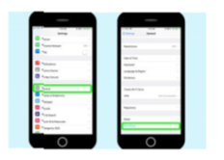
Apple has given iOS 11 users a new way to shut down their device. In the case that your iPhone’s lock/wake button stops working correctly, you can open Settings, tap General, tap Shut Down and swipe the shutdown slider at the top of the screen. You might also get it to shut down by holding down the lock/wake button until the screen goes black. If you cannot get your device to wake up by holding down the lock/wake button, plug your iPhone into a power source and it will start up.

Handwritten Emails
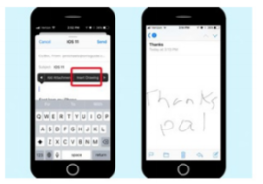
Last year’s iOS 10 update added the ability to send a text in Messages in your own handwriting (or at least in whatever you could scrawl on an iPhone-sized screen). In iOS 11, Mail adds that capability. Just long press on the screen to summon up the copy/paste pop-up window; scroll through all the options until you reach Insert Drawing. Tapping that option takes you to a blank page where you can use a virtual pencil, pen or marker to write out a message. When you’re done, you can insert it directly into the body of an email.

New screen effects for Messages
It’s not exactly a hidden feature, but unless you poke around in the Messages app, you may not know Apple has added two new screen effects to augment the text-enhancing features it first introduced in iOS 10. Joining the likes of Balloons and Fireworks are Echo and Spotlight, which pretty much do what their names imply. Echo repeats your message in a flurry of text across the screen while Spotlight shines a beam of light around your message.

Easy, breezy new device setup
One of the biggest pain points in buying a new iPhone will be solved, thanks to Automatic Setup. By simply holding a new iPhone or iPad near an iOS device or Mac you already own, you’ll transfer over your personalized settings as well as your iCloud Keychain passwords.

Safari Additional Privacy
In Settings navigate to Safari and you’ll see a ‘Try to Prevent Cross-Site Tracking’ option. This stops ads following you from site to site; it is enabled by default. Password

Autofill - Saved passwords in Safari can now be (securely) integrated into third party apps, saving you time typing them in.

Flight Status - In iOS 11 flight information is grabbed automatically from your emails and calendar and can be kept visible in Safari or a Spotlight widget.

Smart Storage Recommendations - In Settings ‘Storage and iCloud Usage’ has been renamed ‘iPhone/iPad Storage’ and it offers recommendations for saving space with options such as auto deleting old conversations, removing large iMessage attachments and storing messages in iCloud.

Auto App Removal - Go to Settings -> General -> iPhone Storage and iOS 11 gives you the option to automatically delete lesser used apps when low on storage. All data and settings are saved so nothing is lost, and the app will return when storage is freed up.

Drag and Drop iPhone Drag and Drop
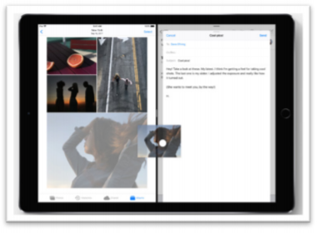
Widely marketed as an iPad feature, this works on the iPhone in the Files and Notes app among others. Until all apps support this, however, finding what does and doesn’t work takes time.
Drag and Drop is listed in iOS 11 for iPad only, but it can be used on iPhone.

Phone SOS
You can dial 911 if the Sleep / Wake / Power button is pressed quickly five times. Auto Answer - Not many users will want this enabled, but if you suffer from a disability it could prove vital. Go to Settings -> General -> Accessibility -> Call Audio Routing -> Auto-Answer Calls and you can set a time period of up to 60 seconds by when calls will be answered automatically.

Notes now includes a scanner.
In iOS 11, you will find one of the biggest additions to notes — a scanning feature — is available to iPhone and iPad users. Tap the circled plus sign in the format menu, and then choose the Scan Documents option. That turns your iPhone’s camera into a scanner that can import documents, receipts and other hard copies into Notes where you can then mark them up, save and/or send them.

Source and Compliments of www.forbes.com and www.tomsguide.com

